IMMIGRATION TEAM UPDATE
  - May 2018, Goldsmith Chambers
end TO the “hostile environment”?
Sajid Javid was announced as Home Secretary on 30 April, following Amber Rudd’s resignation for inadvertently misleading Parliament regarding Home Office removal targets in the wake of the Windrush scandal.
In his first appearance in Parliament as Home Secretary, Javid distanced himself from the language of a “hostile environment” for illegal immigrants, coined by then Home Secretary Theresa May in 2014.
"I think the terminology is incorrect, I think it's a phrase that is unhelpful and does not represent the values as a country,” Javid told MPs.He went on to say that he preferred the phrase "compliant environment"
It is not yet clear whether and how the difference in language will translate to concrete policy changes.
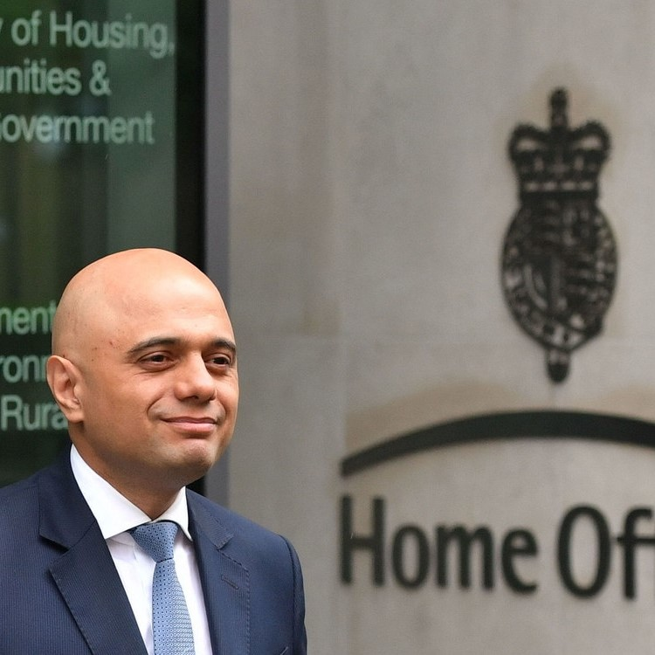

NEW BAIL GUIDANCE FOR IMMIGRATION JUDGES
The President of the IAC, Judge Clements, has finally got around to issuing new guidance following January’s raft of changes to the immigration bail system wrought by Schedule 10 to the Immigration Act 2016.
In the most surprising change, the new guidance provides that Judges must not encourage the withdrawal of applications on the day as an alternative to refusing bail. A common tactic when listed before certain Judges or where a clear preliminary view is given, Judges are now being told to scrutinize any withdrawal and that in most cases it will be more appropriate to refuse.
“…it is likely at that stage in the proceedings that it will be in the interests of justice to refuse bail rather than accept the withdrawal.”
Bearing in mind the result of any refusal is that any further application made within 28 days will have to overcome a preliminary hurdle of there having been “a material change in circumstances”, the practice of many Judges to encourage withdrawal often provided a fairer, more reasonable outcome.
It is yet to be seen how fair-minded Judges will implement this guidance and whether the approach to “a material change” will correspondingly soften. Often the making of an application causes a flurry of Home Office activity, with the result that the situation by the day of the hearing is markedly different. It is hoped that withdrawal will still be accepted in such cases.

DAMNING APPEAL FIGURES CONDEMNED BY LAW SOCIETY
A press release from Law Society President Joe Egan has pointed to delays, spiralling fees and figures that almost 50% of immigration and asylum appeals are allowed, as demonstrating “serious flaws” in the way applications are being dealt with by the Home Office. In a statement, Egan said:
“These grave problems in our immigration and asylum system undermine the rule of law, while also damaging our country’s reputation for justice and fairness. We need an immigration and asylum process that is fit for purpose and that makes lawful, timely, consistent decisions.
“Given the three million EU nationals residing in the UK who may soon want certainty about their immigration status, the need for a robust, reliable and efficient immigration system is more pressing than ever.”
Whilst practitioners on the ground will be wearily familiar with such complaints, it is hoped that such statements will bring the spotlight onto what is an increasingly hostile, expensive and unfairly managed system.

EU CITIZENS: GEARING UP FOR BREXIT
A report by the Migration Observatory at Oxford University highlights the risk that many of the 3-4 million non-Irish European Citizens currently in the UK will end up without paperwork permitting them to remain after Brexit.
The report, “Unsettled Status? Which EU Citizens are at Risk of Failing to Secure their Rights after Brexit?”, noted particular concerns that vulnerable groups, such as the elderly, children and those with mental health disorders, may not know or be able to complete the application process for transferring their status to leave under the Immigration Rules.
Under the current policy envisaged by the Government, anyone who, by 31 December 2020, has been continuously and “lawfully” living in the UK for five years under EU law will be able to apply for ILR. Anyone who is already in the UK under EU law or who arrives by 31 December 2020 will be granted some form of leave until they are eligible for ILR. At present, in respect of other family members who might later wish to join such people it is stated that:
“Close family members (spouses, civil and unmarried partners, dependent children and grandchildren, and dependent parents and grandparents) will be able to join EU citizens after exit, where the relationship existed on 31 December 2020.”
As Brexit looms, it is important that anyone affected is fully aware of all announcements from the Home Office regarding the system that will be used to administer the application process. Ministers have stated that it will be a streamlined, online process at the same cost as a British passport (currently £75.50). There has even been talk of a mobile app. However, nothing has been confirmed at this stage. Of course, many people will still need assistance throughout the process, not least in gathering all the evidence which no doubt will be specified and rigorously administered by the Home Office.

RECENT CASELAW NEWS
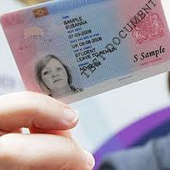

Upcoming Goldsmith Events

- Book launch party: 10th edition of Phelan’s “Immigration Law Handbook” publication and new editing team celebration – date TBA

- Chambers seminar on Surinder Singh post Banger: including talks by Counsel who represented Ms Banger in the CJEU – date TBA
Supreme Court to rule on the effect of children in article 8 cases
In what is set to be a decision with enormous ramifications on the ground, the Supreme Court is currently considering what factors should be taken into account within the “reasonable” and “unduly harsh” tests contained in Part 5 of the NIAA 2002 (and the Immigration Rules).
The position following MA (Pakistan) and MM (Uganda), the two leading Court of Appeal authorities, is that the tests require a full assessment of all relevant public interest criteria. In practice this has meant that other factors, most commonly the immigration history and any criminality or previous conduct of the parent, have provided the Home Office with arguments to succeed in resisting otherwise strong family life claims where children are involved.
The claimants have sought to challenge that reading, arguing that the focus should instead be entirely on the position of the child. They argue that other factors are irrelevant on a correct reading of the statutory “exceptions” inserted by the Immigration Act 2014. If the Court agrees, it will mean that article 8 claims relying on a parental relationship with a qualifying child will stand a much better chance of succeeding. The Supreme Court heard the case in April as NS (Sri Lanka) & Others, with judgment expected in 3-6 months.
NS and the linked appellant AR were represented by Charlotte Bayati of Goldsmith Chambers.

Banger: CJEU to consider Surinder Singh unmarried partners
A number of hugely important questions relating to whether the principles in Surinder Singh apply to unmarried partners as they do to spouses is currently being considered by the Court of Justice (C-89/17 Secretary of State for the Home Department v Banger).
Following the hearing in March, in which Ms Banger was represented by Anthony Metzer QC and Sanaz Saifolahi of Goldsmith Chambers, Advocate General Bobek has delivered his Opinion and it is in favour of the applicant’s argument that the principles apply equally in respect of those in a durable relationship. If the Court agrees, this could widen the route to include unmarried partners for the first time. The final question referred by the UT, whether in such cases JR is an adequate remedy or a right of appeal is required, was considered by the Advocate General to be a matter for the domestic courts. The Court’s judgment is expected in 3-6 months.

New Country Guidance on risk in Kabul
In AS (Safety of Kabul) Afghanistan CG [2018] UKUT 00118 (IAC), UT Judges Allen and Jackson considered some of the latest objective evidence coming out of Kabul. Although the Tribunal reiterated that every case will turn on its particular facts, the general rule for the foreseeable future will be that anyone of “lower interest” to the Taliban will not be at risk on relocation to Kabul.
This decision will particularly affect single adult males in good health, whom the Tribunal specifically identified as not being at general risk. Whilst factors such as age, education, health (physical and mental) and the level of support available will all still be relevant, the starting point is that relocation to Kabul will not in general be unreasonable or unduly harsh.

FTT’s limited jurisdiction in statutory appeals
In Charles (human rights appeal: scope) [2018] UKUT 00089 (IAC), the UT confirmed that a human rights appeal can be determined only through the prism of the ECHR. This decision spells the end to the jurisdiction recognised in Greenwood No. 2 to allow an appeal on the ground that it is not in accordance with the law (where, for example, the SSHD has wrongly applied the Immigration Rules).
Whilst an assessment under the Rules will still be highly relevant under article 8, and the jurisdiction is wide enough to incorporate any previous errors by the SSHD into the human rights matrix, issues may arise in cases where there has been a refusal of ILR in another category of the Rules. In such cases, the FTT can no longer direct that the decision be reconsidered outside the confines of human rights. Even if allowed under article 8, it is open to the Home Office then simply to grant limited leave as in any other allowed appeal.
This is another reminder of the limited scope of the current appeals regime in Part 5 NIAA 2002, leaving judicial review as the only remedy following a bad decision under the PBS or other categories of the Rules.

“New matters”: Mahmud confirmed
In Quaidoo (new matter: procedure/process) [2018] UKUT 87, the UT has approved and applied the unhelpful decision of Mahmud in relation to what constitutes “a new matter” requiring the consent of the SSHD to raise in an appeal brought under the NIAA 2002.
It remains the case therefore that any new “factual matrix” not previously considered, invariably including the birth of a child, will be a “new matter”, even where this could easily have been anticipated. Anyone aggrieved by a refusal to consent only has a remedy in JR.

High Court names and shames immigration lawyers for spurious injunction applications
In another damning judgment, a number of solicitors have been referred to the SRA amidst highly critical remarks about practitioners in the field of immigration and asylum law. The latest in the Hamid line of cases, the Courts are taking a hard line on the practice of issuing last-minute claims designed to frustrate removal which are later found to be without merit. Given the risks, those thinking about making such claims are strongly urged to give realistic advice to clients and to seek the opinion of Counsel prior to starting the process.

SSHD criticised following “appeal everything” approach in deport cases
The Court of Appeal has condemned the SSHD for her conduct in alleging systemic failures in the approach of the UT to deportation appeals, before subsequently abandoning the point at the appeal hearing. The Court went so far as to make an award for costs to the claimant on an indemnity basis, Singh LJ describing the conduct as “unreasonable to a high degree”. Such comments will no doubt be refreshing to practitioners familiar with the Home Office’s blanket policy of contesting all deportation appeals, regardless of merit.

